Submitting your Seating audition

Record all excerpts on a single track, NOT separate tracks for each excerpt. Audio recordings, NOT video.
- What works well is to record from your phone/device (Voice Recorder on an iPhone, etc.), as the recordings will typically be auto-compressed, making them small enough to upload. Preferred file types are mp3, mp4, WAV, and m4a.
- Do NOT say your name. Simply play through all excerpts without stopping the recording between. (Cycle 1 excerpts are listed below)
- Do NOT RENAME your file (unless there is something in the file name that identifies you. Remember, these are BLIND auditions and the conductor should not know who they are listening to.)

- Save your file to your computer (i.e. email it to yourself and download to your desktop) If you do not have access to a computer you should be able to do it from your phone but it might be a little trickier.

- Once your recording is ready, follow the next steps!

Log into your Acceptd account.
https://getacceptd.com Log In enter email and password you created when you auditioned last summer for IYO

You will see a box similar to the one below. Click the orange CONTINUE button



Click ATTACH MEDIA

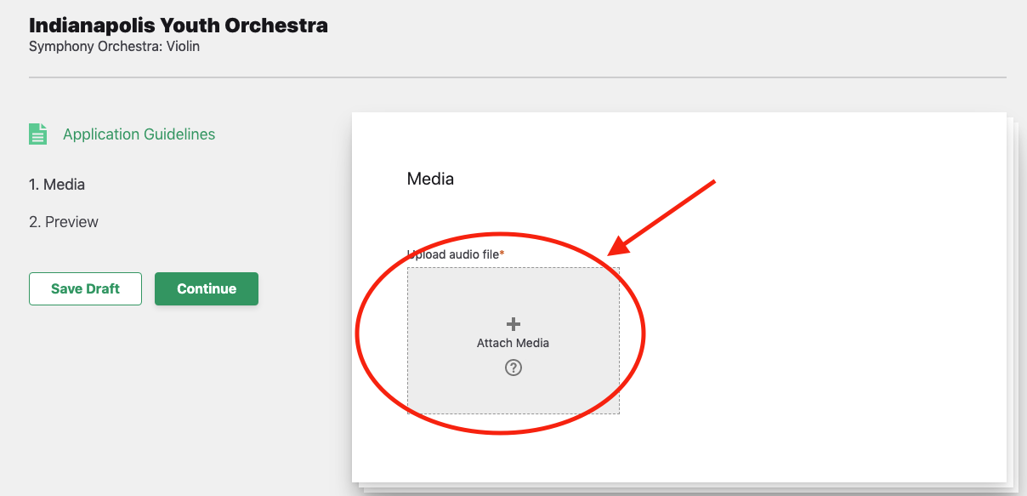

Drag and drop your file into the gray box (or click the gray box and select file from your computer)

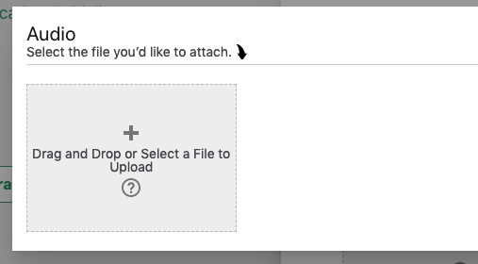

Once your file as completed uploading, you are ready to click SUBMIT. You’re done!

Symphony Orchestra Cycle 1 excerpts
2021-2022

Violin 1
Death and Transfiguration Letter H to Molto Agitato after Letter K
Goal Tempo – quarter = 120-130
Emperor Waltz No. 4 mm. 21-63
Goal Tempo – bar = 55

Violin 2
Death and Transfiguration Letter R to Letter T
Goal Tempo – quarter = 120-130
Emperor Waltz mm. 29-67
Goal Tempo – half = 76

Viola
Death and Transfiguration mm. 1-5
Goal Tempo – quarter = 48
Appassionato after Letter O to five before Letter R
Goal Tempo – quarter = 120-130

Cello
Death and Transfiguration 2nd full measure of Allegro molto agitato to 5th of Letter F
Goal Tempo – quarter = 120-130
Emperor Waltz No. 4 mm. 21-63
Goal Tempo – bar = 55

Bass
Death and Transfiguration 2nd full measure of Allegro molto agitato to 5th of Letter F
Goal Tempo – quarter = 120-130
Emperor Waltz No.3 m.52 to4th measure of No.4
Goal Tempo – bar = 60

